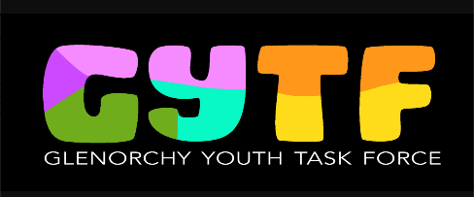
Glenorchy Youth Task Force
Expression of Interest
The Glenorchy Youth Task Force (GYTF) is a group of young people who have a passion for working with other young people and a desire to make a difference, including creating positive experiences, relationships and places for young people. It is the longest running youth advisory group in Australia and was established in 1994.

Membership is free and open to young people who live, attend school, work or spend a lot of time in, the City of Glenorchy (which covers Moonah to Granton on the west side of the Derwent River and includes Collinsvale).

GYTF meets 4pm Tuesday fortnightly at Glenorchy City Council Chambers (374 Main Road, Glenorchy opposite Northgate). Online meetings are sometimes held where necessary.

The Glenorchy Youth Task Force:

provides advice to Glenorchy City Council on youth issues,

raises concerns on behalf of young people,

promotes equal access for young people to Council services, and

undertakes projects and/or events which improve the City of Glenorchy for children, youth and families.

Who can join?
- Individuals aged 13 years up to 25 years
- You should have a strong connection to the Glenorchy City Council area e.g.
  - live in the Glenorchy City Council area;
  - or attend school, or work in the Glenorchy City Council area
  - or spend a lot of time in the Glenorchy City Council area
- You have an understanding of youth issues

Your commitment:
- Attend and participate in fortnightly meetings
- Help to plan, participate and deliver community events and/or projects
- Represent the young people of Glenorchy
- Contribute to consultations with community groups and governments
- Face challenges and drive positive change as part of a team

Glenorchy Youth Task Force
Expression of Interest Form
Name: Click or tap here to enter text.
Age: Click or tap here to enter text.
Date of birth: Click or tap here to enter text.
Email: Click or tap here to enter text.
Address: Click or tap here to enter text.
Mobile phone: Click or tap here to enter text.

School (if applicable): Click or tap here to enter text.

Emergency Contact:
Name: Click or tap here to enter text.
Relationship: Click or tap here to enter text.
Mobile Phone: Click or tap here to enter text.
Email: Click or tap here to enter text.

- Why would you like to be a part of the Glenorchy Youth Task Force?
Click or tap here to enter text.

- Tell us more about yourself (e.g. interests and hobbies)?
Click or tap here to enter text.

- What ideas do you have to make lives better in the City of Glenorchy?
Click or tap here to enter text.

Who referred you to the Task Force?
I referred myself ☐
Parent ☐
Education Dept ☐ Worker ______________________________
Other ☐ Worker _______________________________

For parents/carers:
The Council will take reasonable steps to reimburse members for travel to and from meetings by providing free bus tickets and occasionally providing taxi vouchers when considered a safer option. The Community Development Officer in attendance at meetings will provide their work mobile number to the task force and ensure members return home or to their next destination safely. The Community Development Officers may consider making an agreement with parents of members under 18 years regarding their travel arrangements to and from meetings and activities.

Please return this form to:
Conrad Gilbey at Glenorchy City Council conrad.gilbey@gcc.tas.gov.au

Questions?
Please contact Conrad Gilbey
Community Development Officer - Children, Youth and Families
Glenorchy City Council (03) 6216 6766 Email: conrad.gilbey@gcc.tas.gov.au

